Basic working Test
Aim
To test basic working of raspberry pi rain gauge

hardware Connection
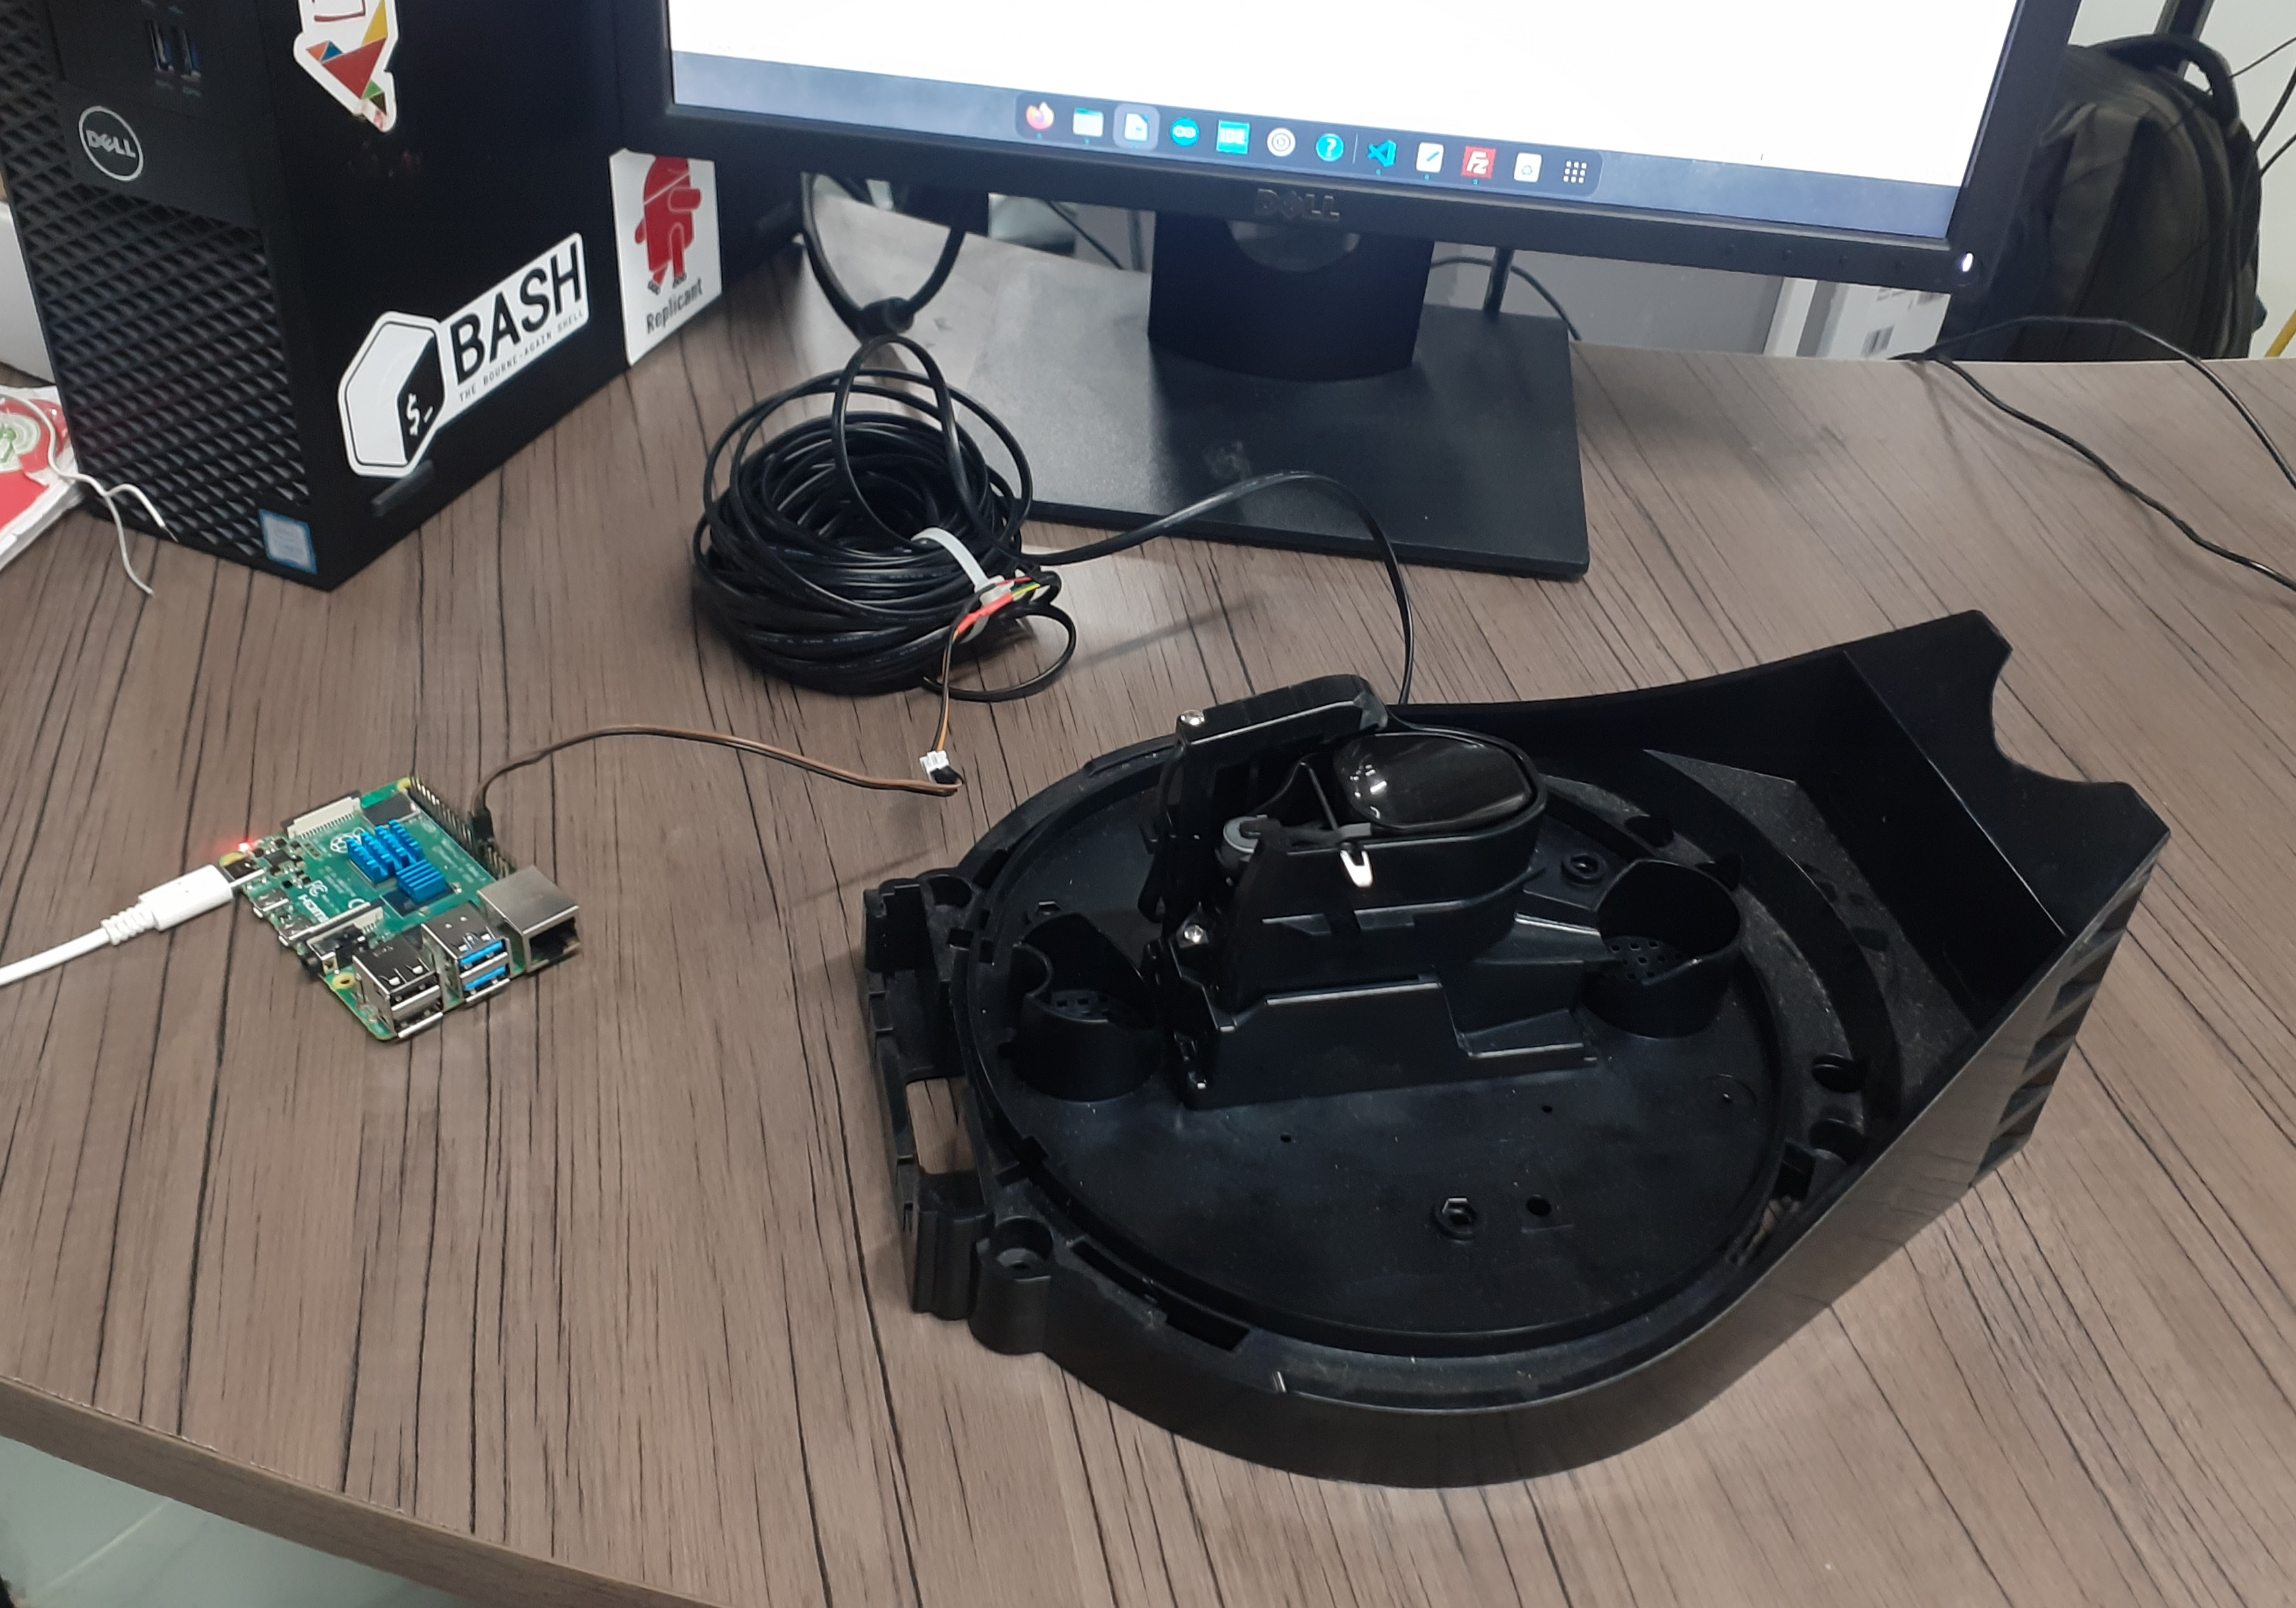
GPIO 13 pin and the GND pin are connected to two wires of the Davis tipping bucket rain gauge. The operation of the rain gauge is simulated by manually closing the switch.raspberry pi is powered using its charging module.

Software setups
Raspberry pi 64 bit OS is installed in memory card using imager softaware.this memory card will act as a OS source for raspberry pi when you put it in memory card slot.
I didnt have a monitor for raspberry pi during testing.so im using SSH protocol for accessing raspberry pi.using SSH you can control and modify raspberry pi files.using the same way we can install and run our test code in it(here i used filezilla application for transferring files to raspberry pi).

Inorder to attain SSH communication raspberry pi must be connected to internet.Network configuration of raspberry pi can be done by two ways .setup network configurartion during OS installation using imager or do it after installing OS (you may need a display setup for this).
In this case i configured wifi connectivity to raspberry pi during OS installation and made its IP address static (how to do it ?) to make SSH connectivity easy.Now our setup will automatically connect to wifi network when its powered ON.

we can access terminal of raspberry pi from our system using SSH protocol.you just need know IP address, user name and password.When you successfully established a connection between raspberry pi,you can modify files in it and control it.by this way we can install and run our test code in it(here i used filezilla application for transferring files to raspberry pi).
Python is inbuilt in Raspberry pi OS so we dont need to install it.you just need to install Rpi.GPIO library using command “pip install Rpi.GPIO”.you may need to reboot the device after installation.
After all this setup run our python code using terminal.

Findings
The updated code is running successfully. it is calculating and printing rainfall data in every 10-second intervals.

